DDCAS Demonstration
This document contains brief instructions for running the DDCAS_Demo Matlab code accompanying the paper:
A new algorithm for initialising online and evolving clustering and eliminating start up times, R Hyde, R Hossaini, A Leeson, submitted to Data Mining and Knowledge Discovery Jan 2018.
The software is written in Matlab ver 2017a, but will probably work on earlier versions although this has not been tested. The software will reproduce the analyses and figures contained in the paper.
The source code is all in readable format. Copyright is retained by the authors and the code is released under Released under the GNU GPLver3.0. You may have received a copy of the GNU General Public License along with this program. If not, see http://www.gnu.org/licenses/. No warranty is provided, the code is not intended for any other use. While every effort has been made to remove software bugs, and improve usability, this software should not be considered ‘complete’ and care should be taken when using any of the results or outputs.
The author would like to acknowledge the use of the following functions not written by him:
distinguishable_colors.m by Tim Holy. Downloadable from Matlab’s File Exchange at:
https://uk.mathworks.com/matlabcentral/fileexchange/29702-generate-maximally-perceptually-distinct-colors?s_tid=gn_loc_drop
circles.m by Chad Green Downloadable from Matlab’s File Exchange at:
https://www.mathworks.com/examples/matlab/community/20229-circles

Introduction
Running DDCAS_Demo.m from within Matlab brings up a GUI for ease of running the analyses contained in the paper. The software should not be considered ‘production ready’ as error catching etc is not fully implemented, however it should perform reasonably well if care is taken in its use. Not that on slower computers some selections may be available prior to the GUI initialization finalizing and may produce an error. In most cases the GUI can continue to be used without re-starting. The GUI has been designed for a screen resolution of 1920x1200. It should run on lower resolutions, however some sub-windows may overlap and/ or text become obscured.

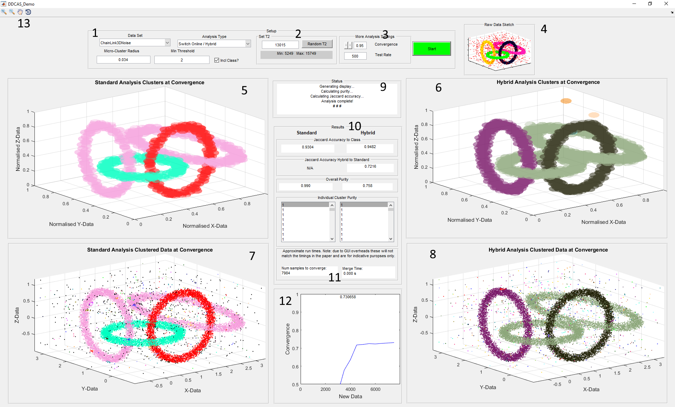

1
This region of the GUI sets up the datasets, cluster parameters and tests allows you to select:

Data Set
3 data sets are included as detailed in the accompanying paper.

Analysis Type:
Each of the tests detailed in the paper can be selected here

Micro-Cluster Radius:
Default values appear here. These can be changed by the user to allow exploration, but the results may be poor. Note: the paper discusses the initialization of the underlying clustering algorithms and is not intended to discuss the details of the clustering algorithms themselves. The data sets are designed to stress test the algorithms and are, therefore, difficult to cluster.

Min Threshold:
This is the minimum cluster membership threshold at which the user would distinguish between random noise and genuine data.

Incl Class:
If the data set is known and incudes a column of classes then this box is checked. If using another data set, check this box as appropriate.

Start:
To the right is the start button. Of course, this starts the analysis with the parameters chosen. If T2 has not been selected it will not run. When the analysis is running the button changes to red and reads ‘Interrupt’. The user inputs cannot be changed while the analysis is running. Clicking interrupt will interrupt the analysis. After analysis is complete, the button does not interrupt the plot routines.

2
This section provides randomization of test parameters T2. The user can type in a value for T2, to allow test repetition, or click the ‘Random T2’ button to generate a random value for T2. The ‘Minimum’ and ‘Maximum’ values provide the values between which randomization will occur. These are selected to prevent data set end conditions affecting the results. For online and evolving clustering the data streams would be considered endless an so end condition do not occur. The user can input T2 outside of these values.

3
More analysis settings. For some tests additional setting are required and they appear here when applicable.

Convergence:
The value at which convergence is considered to have occurred, i.e. the two clustering techniques have produced results with this level of agreement. Note, this convergence value is based on the macro-clusters only, not including the outliers. Thus, the value provided in ‘10’ for the similarity may differ as that value does include the outliers. For the synthetic data, the data need to be randomised due to it’s non-cyclic nature. Thus the results obtained during each run will vary slightly and may not exactly match those presented in the paper.

Test Rate:
The number of data sample between tests. The convergence test can be time consuming, particularly where a large number of historical data samples are considered.

4
The ‘Raw Data Sketch’ window shows an outline view of the dataset loaded. If the data set contains classes then the data will be coloured appropriately.

5, 6, 7 & 8
These windows provide visualization of the results of the clustering algorithms. 5 & 6 display the cluster regions, & & 8 show the data samples.

9
Status window. Messages appear here to inform the user of the progress of the analyses.

10
Results. This panel shows the comparisons between the clustering techniques and the original classes as well as between the hybrid-DDCAS technique and the standard online or evolving algorithm. The individual purity of each cluster is also shown. The purity list may be long where the data set contains noise as each noise datum may be an individual cluster.

11

This window is not visible for tests 21 & 2. For test 3 this display the number of samples required for convergence and the time taken to run to convergence. This time is calculated by re-running the clustering to convergence without any additional work slowing the process, e.g. parallel clustering etc.

12
This window is not visible for tests 21 & 2. For test 3 this window shows the convergence progress. This window is not visible for tests 21 & 2.

13
Controls for manipulating the plot windows. Due to the limited number of distinguishable colours for the plots relative to the high number of clusters where noise is present the main cluster may appear the same colour. Using these tools the view can be zoomed and rotated to clarify the cluster are, in fact, separate.

